The LAWRENCE GARDEN CLUB PRESENTS ITS
78th FLOWER SHOW:
WHERE YOU ARE PLANTED

At the VBDL Lawrence Branch Library
212 N. Paw Paw Street, Lawrence, MI 49064

Friday-Aug. 2, 2024 1pm-5pm
Saturday, Aug. 3, 2024 10am-3pm

Open and Free to the Public

Member of National Garden Clubs, Inc.
Michigan Garden Clubs District III

2024 Show Committee: Nancy Baker 269-308-1377
Rosanne Boyan 269-307-4067
Anne Cox 269-674-3200

GENERAL RULES

- All Design and Horticulture Classes are open to the public. However, Certified Flower Show Judges may not enter this show.

- Show Schedules and Entry Cards will be available from the VBDL Lawrence Library beginning on July 1, 2024. Show schedules also found on the Lawrence Garden Club Facebook page and/or at www.lawrencegardenclub.com.

- Entries will be accepted at the VBDL Lawrence Library on Thurs.- Aug. 1 between 5:30pm and 7pm and on Friday- Aug. 2, 2024 between 7:30am-10:30am.

- Judging will begin at 11:00am on Friday-Aug. 2nd. Only the General Chairmen, the Classification Chairmen, and the clerks will be allowed on the show floor during the time of judging. Judging will be by the NGC Standard System of Awarding, Handbook for Flower Shows Revised 2017 Edition and additions found in The National Gardener.

- The Show Committee Members and the Classification Chairmen for the Design and Horticulture Divisions must be available during all judging to review all entries for proper identification and for possible consultations.

- The decision of the judges is final. Awards may be withheld if not merited. Plants on the state’s endangered or conservation plant list must be grown by the exhibitor or collected in a legal manner and so identified. (State policy prevails.) Noxious weeds and plants on the state’s invasive plant list will be so marked. Lists can be downloaded at www.michigan.gov.

- There must be an emphasis on fresh plant material. No artificial plant material will be allowed in any division.

AWARDS

The NGC Standard System of Awards.
* One first place (blue) ribbon per class for score 90 or above.
* One second place (red) ribbon per class for score 85 or
above.
* One third place (yellow) ribbon per class for score 80 or
above.
* One or more honorable mention (white) ribbons as merited
for score 75 or above.
Judges will sign, date and write 90+, if merited, on entry
cards that do not win a blue ribbon.

Top Exhibitor Award will be awarded in Floral Design
Division.

Top Horticultural Award will be given in the
Horticulture Division.

People’s Choice Award will be granted to the Floral Design
entry selected by popular vote of show visitors.

Youth Award will be offered for young exhibitor scoring
most points overall in Design and Horticulture Divisions.
Entries in both divisions are required.

The winning exhibits must be blue ribbon winners scoring
90 or above, and the winning horticulture exhibit must be
correctly named according to schedule specifications.
Gift Certificates from area businesses will be presented to
winners of each award listed above.

DIVISION I: FLORAL DESIGN RULES

- Small Standard Flower Shows must have a minimum of three (3) classes that each have a minimum of four (4) entries.

- A design entered in competition must be the work of only one exhibitor; that exhibitor’s name must appear on the entry card that lists plant materials and simple narrative of design choice on an attached 3”x 5” card.

- An exhibitor may enter as many classes in the Design Division as desired unless the schedule limits the number of entries, but only one exhibit per class.

- Fresh plant material may not be treated in any manner. Plant material that has been treated to alter its exterior appearance may be used only in its dried state.

- The designer has the freedom to choose Traditional or Creative style with any design type listed unless restricted by schedule.

- Plant material used in Design Classes need not have been grown by the exhibitor.

- No artificial flowers, foliage, fruits or vegetables are permitted in the Design Division.

- Landscapes or scenes are not permitted in the Design Division. Inappropriate or offensive display of religious icons or the American flag is not allowed.

- Refer to Chapter 7of the NGC Handbook for Flower Shows for things permitted in all design classes unless prohibited by the schedule or by law.

- The Design Scales of Points are listed in Chapter 14 of the NGC Handbook.

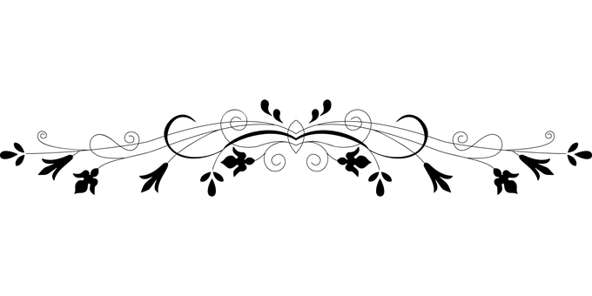

FLORAL DESIGN CLASSES

CLASS 1: High on a Sunny Hill – Fresh Arrangement; over 8”

CLASS 2: Between a Crack in a Sidewalk - Fresh Arrangement;
under 8”

CLASS 3: Deep in the Cool Woods - Fresh Arrangement; single
flower w/filler

CLASS 4: Along a Country Road- Fresh Arrangement by YOUTH;
any type/size

CLASS 5: At a Picnic in the Park – Tablescape Setting for Two;
Fresh Arrangement any type/size

CLASS 6: In a Small Town Like Lawrence - In memory of Mary
Webster; Fresh Arrangement; any type/any size

DIVISION II: HORTICULTURE RULES

- Small Standard Flower Shows must have a minimum of five (5) Horticulture Classes, each having a minimum of four (4) entries.

- Classes are open to amateur growers and all plant material must be fresh and grown by the exhibitor.

- Exhibits must have been in the possession of the exhibitor for no fewer than 90 days. Exception: plants grown from seed, seedling, or immature transplants, bulbs, tubers, corms or rhizomes. Combination plantings must have been grown together for no fewer than 6 weeks.

- Plant material may not be altered by the application (treatment) of oil, commercial “shine” products, etc. that artificially change the natural color and texture.

- All specimens must be correctly labeled with scientific (botanical) names or the currently accepted scientific identification for their educational value. Common name may also be added.

- An exhibitor may make more than one entry per class if each entry is a different species, variety, cultivar, type or color.

- Cut specimens must be displayed in clear transparent bottles provided by Lawrence Garden Club of suitable size and stability. Cut specimens should not have foliage below the water line.

- Wedging, a small, inconspicuous “plug” in the neck of a
container to improve the pose of specimen, is permitted.
Wedging may be visible but must not detract from the cut
specimen. Wedging will be provided by the LGC and must
be inserted by exhibitor.

- Double potting is permitted; inner pot must not be visible.

- Fruit and Vegetable specimens must be free of disease and injury. White paper plates will be provided at show to display entry.
- All entry cards should be filled out in advance and clearly legible; if handwritten, entry should be in pencil or water-proof pen to avoid water damage.

- The Classification Chairman has the authority to subdivide classes as necessary.

- The Scale of Points for judging horticulture is listed in Chapter 14 of the NGC Handbook for Flower Shows.

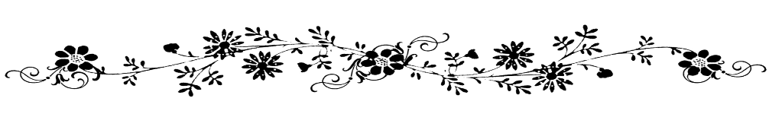

HORTICULTURE CLASSES

SECTION A – CONTAINER GROWN PLANTS (1 plant per
container, unless noted otherwise)
CLASS 1: Cacti (Cactaceae)
CLASS 2: Other Succulents
CLASS 3: Any Ivy or Vine Type Plant
CLASS 4: Any Other Foliage Plants
CLASS 5: Any Other Flowering Plants
CLASS 6: Multiple Plants (3 or more) in Non-Hanging
Container

SECTION B – ANNUALS (Classes may be divided according to
color, flower form, or size)
CLASS 7: Antirrhinum (snapdragon) 1 stem
CLASS 8: Cosmos (cosmos) 1 spray
CLASS 9: Helianthus (sunflower) 1 stem
CLASS 10: Tagetes (marigold) 1 stem
CLASS 11: Zinnia, large (zinnia)
CLASS 12: Any Other Annual Not Listed, exhibited as to
type- (to be divided upon entry)

SECTION C – PERENNIALS AND BIENNIALS (Classes may be
divided according to color, flower form or size.)

CLASS 13: Alcea (formerly Althaea, hollyhock) 1 stem
CLASS 14: Asclepias tuberosa (butterfly plant) 1 stem
CLASS 15: Bella Perennis (common daisy) 1 stem
CLASS 16: Echinacea (coneflower) 1 stem
CLASS 17: Echinops (globe thistle) 1 stem
CLASS 18a: Hosta 1 leaf
CLASS 18b: Hosta flower 1 stem
CLASS 19: Perovskia atripliciflolia (Russian sage) 1 stem
CLASS 20: Phlox paniculata 1 stem
CLASS 21: Rudbeckia (black-eyed Susan) 1 stem
CLASS 22: Any Other Perennial or Biennial Not Listed, exhibited as to type- (to be divided upon entry)

SECTION D - FLOWERING SHRUBS, to be divided upon entry by
type or color
CLASS 23: Buddleia (butterfly bush) 1 stem
CLASS 24: Hibiscus 1 stem
CLASS 25: Hydrangea 1 stem
CLASS 26: Any Other Flowering Shrub Not Listed, exhibited as to type- (to be divided upon entry)

SECTION E – ROSES, to be divided upon entry by type or color

CLASS 27: Hybrid Tea, 1 stem
CLASS 28: Miniature, 1 stem or spray
CLASS 29: Any Other Type Not Listed, exhibited as to type-
(to be divided upon entry)

SECTION F – BULBS, CORMS, TUBERS, TUBEROUS ROOTS-
(Classes may be divided by color, flower form, or size)

CLASS 30: Gladiolus (gladiolus) 1 stem
CLASS 31: Hemerocallis (daylily) 1 stem
CLASS 32: Lilium, Asiatic (lily) 1 stem
CLASS 33: Lilium, Tiger (lily) 1 stem
CLASS 34a: Cannaceae (canna lily flower) 1 stem
CLASS 34b: Cannaceae (canna lily leaf) 1 leaf
CLASS 35: Any Other Bulbs, Corms, Tubers, Tuberous
Roots Not Listed, exhibited as to type-
(to be divided upon entry)

SECTION G – HERBS
CLASS 36: Aromatic, 1 stem
CLASS 37: Culinary, 1 stem

SECTION H – FRUITS & VEGETABLES (Classes may be divided
according to fruit/vegetable type.)
CLASS 38: Edible Leaves
CLASS 39: Fruits
CLASS 40: Roots

SECTION I - MISCELLANEOUS
CLASS 41: Reeds, Rushes, Grasses w/Distinctive Leaf
Structure, 1 stalk
CLASS 42: Reeds, Rushes, Grasses w/Patterned Foliage,
1 stalk
CLASS 43: Reeds, Rushes, Grasses w/Decorative Seed
Heads, 1 stalk
CLASS 44: Any Other Not Listed, exhibited to type, 1 stalk
(to be divided upon entry)

